|  |  |  |  |  |  |
| --- | --- | --- | --- | --- | --- |
| Date | 25-Nov-22 | | | Tester Name | Mayuri Patel |
| Environment | Penfax - Test | | | Login used |  |
| Operating System | Select OS | Version: | Update: | | |
| Software Used | Select Software | Version: | Update: | | |
| Select Software | Version: | Update: | | |
| Release version | 22.4.1 | | | | |
| Title | Add a new Department (for future release testing) | | | | |
| Test Type | Regression | | | | |
| Test Scenario | Create a New Employer | | | | |
|  |  | | | | |
| Expected Results |  | | | | |
| Pass/Fail | Pass | | | JIRA# | N/A |

Describe your steps with screenshots:

Select any Organization

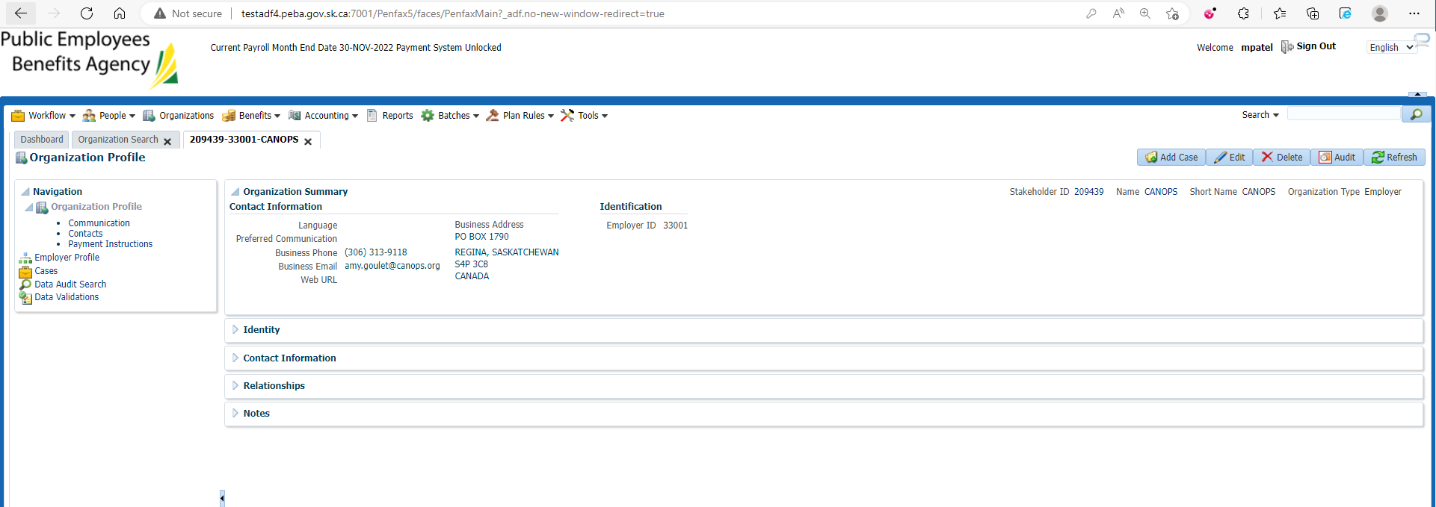

Open Organization Search

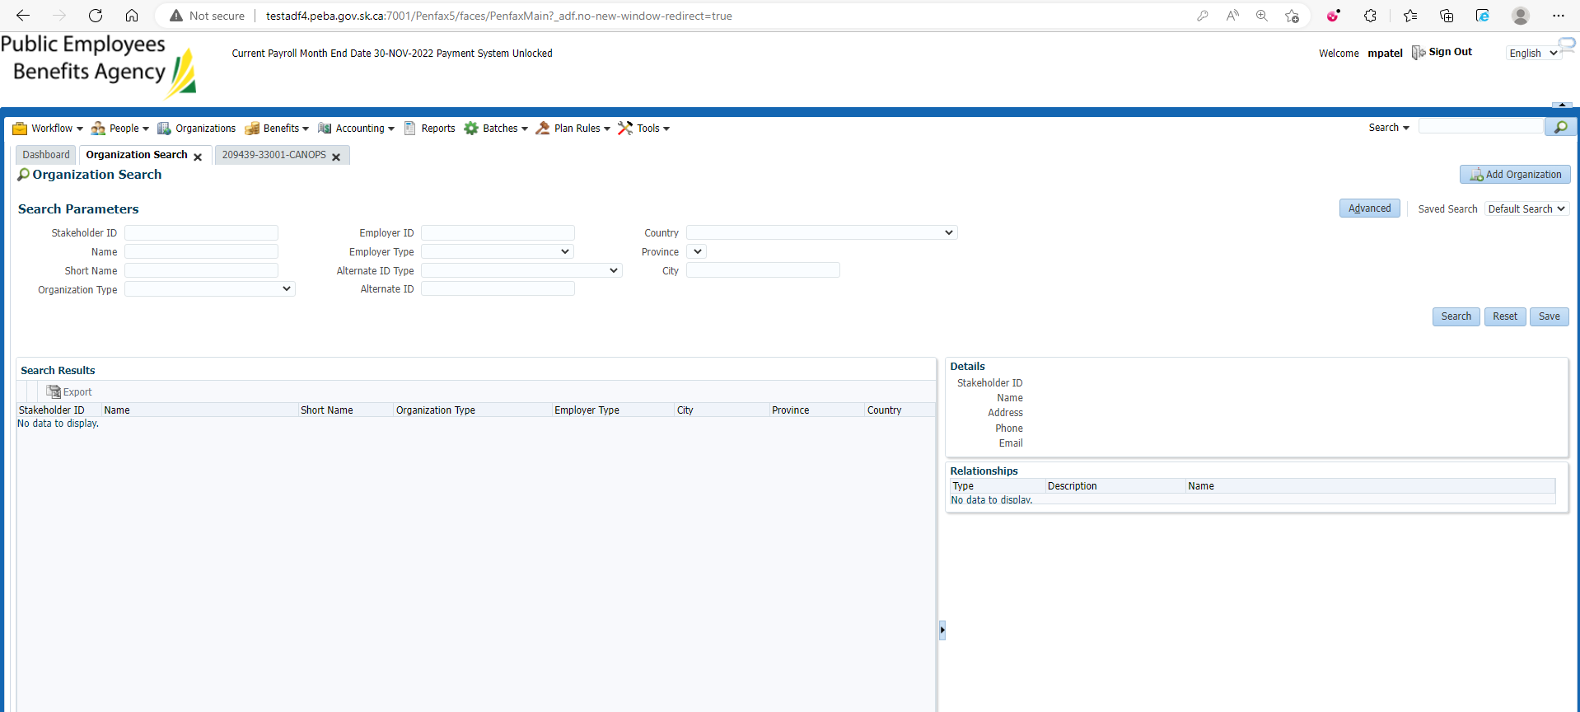

Add organization

Enter Effective date, Organization Type🡪Employer, Employer Type🡪 Department, Employer ID 🡪 4 digit Code and Name of it and then save the details

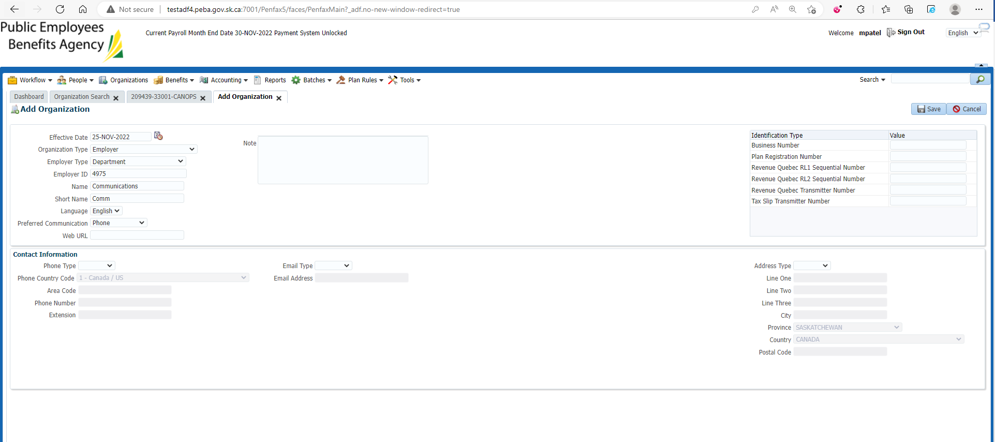

Changes are there

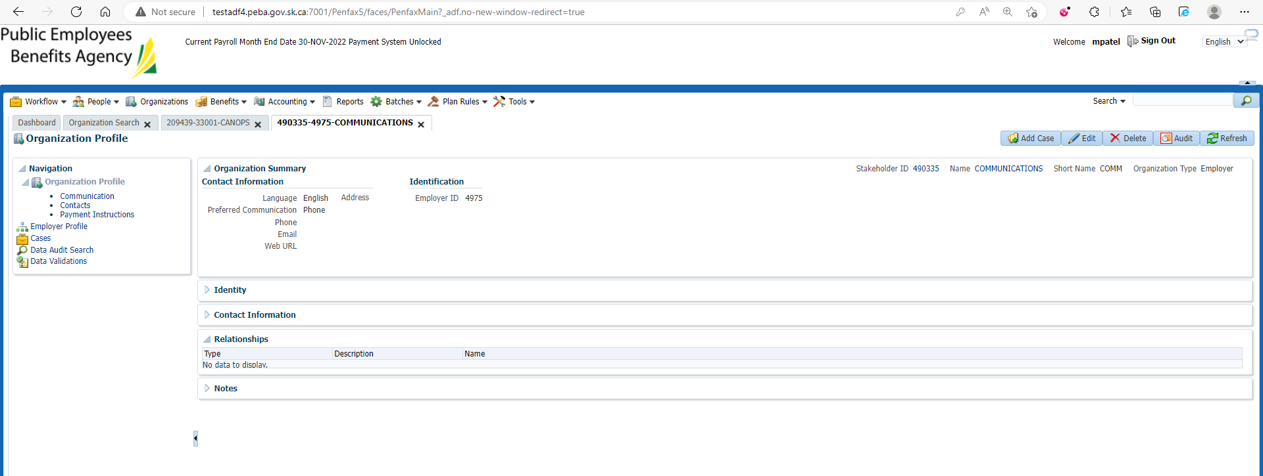

Open selected organization at first step

Under Employer profile 🡪 Departments

Add Department

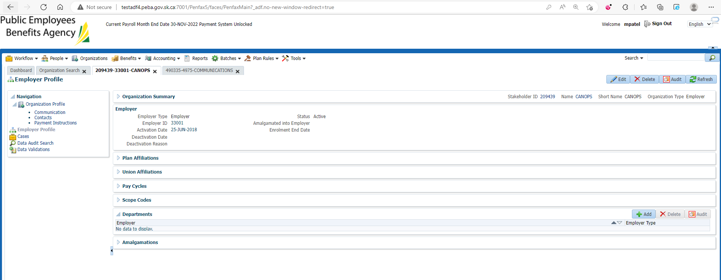

Enter Employer to newly added Department in previous step (select from Dropdown list) and save

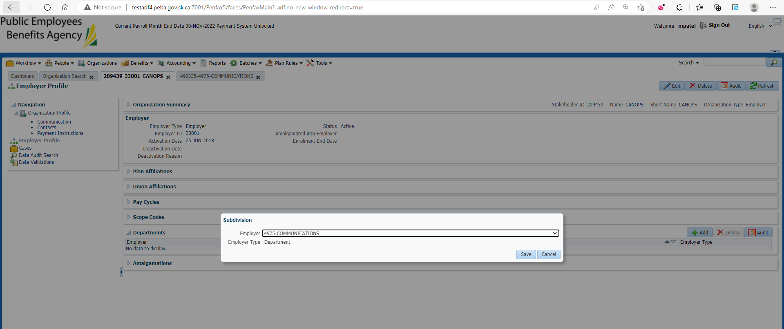

New department is added

